

Four executive style plots for sale
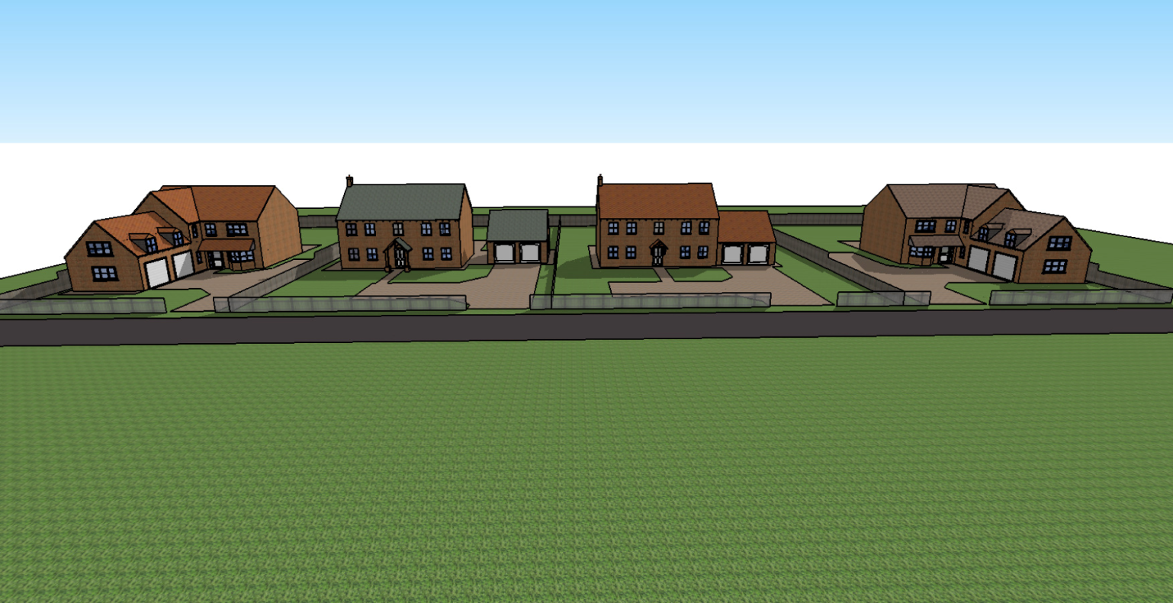
We are pleased and proud to present our latest properties up for sale, here we have a large site that is situated within the tranquil village of Murrow, Cambridgeshire.
WE ONLY HAVE 3 PLOTS AVAILABLE AS ONE IS NOW SOLD!
Each plot has a large south facing rear garden, spacious front garden and each has 4 bedrooms. The master bedroom of course has a built in ensuite shower room!
As you walk into the properties you are greeted by a spacious hallway that leads to an open kitchen dining room with French doors to the garden, perfect for families to get together and share each others days and entertain guests. there is a separate utility that leads to the garden also and can house all the washing facility essentials. the living room is again spacious but kept to a size that is still comforting and relaxing after a hard day at work.

The site is currently clear and waiting to be transformed to accommodate only 4 dwellings that all look out over the countryside. Please contact us now to claim your dream home!

